ICNA Elections 2014
Nomination Form

I, ………………………………………….. (Full name) of………………….. (Country), in Geographic Region ………………………….. (Africa, North or South America, Europe, East Asia-Oceania, or Western Asia) being an Active Member of the ICNA, nominate ………………………………………… (full name), an active Member of the ICNA of………………………(Country) in Geographic Region ………………………….. for election to the Executive Board.

And/ Or

I, ………………………………………….. (Full name) of………………….. (Country), in Geographic Region ………………………….. being an Active Member of the ICNA nominate ………………………………………… (full name) of……………………… (Country), in Geographic Region ………………………….. for election to the position of Secretary.

And/Or

I, ………………………………………….. (Full name) of………………….. (Country), in Geographic Region ………………………….. being an Active Member of the ICNA nominate ………………………………………… (full name) of………………………(Country) in Geographic Region ………………………….. for election to the position of Treasurer.

ICNA Elections 2014
Acceptance of Nomination

I, ………………………………………….. (Full name) of………………….. (Country), in Geographic Region ………………………….., being an Active Member of the ICNA accept nomination for election to the Executive Board or to the position of Secretary or Treasurer (strike out whichever is not applicable)and agree to the conditions for Election, to keep to the requirements to attend all EB meetings, contribute to committees and to organise or participate in one regional educational meeting during my term of office.
EB Nominees should include with this form a statement indicating:
(a) Their current position (work and location)
(b) Other relevant positions (e.g. CNS, EPNS, AOCNA –past / present; journal boards; and
(c) A statement re any significant conflict of interest – such as Pharma employment
(d) One sentence describing why they want to be a member of the EB and what they can add to the ICNA.

Current Members of the EB seeking re-election must also complete the following statement:
I have attended …….. of the five EB meetings held since my election in Cairo (Cairo, Bali, Prague, Brisbane, Kaunas).

Signed Dated

Signed Nominations and Acceptance Forms should be sent by mail to
Caroline Jepps
The Election Centre
33 Clarendon Road
London N8 0NW
United Kingdom
OR
by email to nominations@electoralreform.co.uk
Appendix 1
Arrangement of meetings
There are three types of ICNA meetings:

(1) International Child Neurology Congresses (ICNCs) - These are major meetings with a fixed infrastructure, a Professional Congress Organiser(PCO) and entailing significant input and work from the ICNA EB as well.

(2) Educational meetings - These are usually based on a key board Member being contacted by a local centre which takes on the local infrastructure organization. The board member identifies other invited speakers; they access their own travel funds and ensure the other invited speakers are covered to travel to the meeting. Innovations in this type of educational support have included encouraging ICNA members in general to be part of these programs, not just board members. The education committee now has an extensive portfolio of potential speakers available to be part of such meetings. The education committee does have limited funds to support the travel of highly motivated speakers. The regular board meetings attended by all available members of the ICNA board fall under the "educational meeting" heading. At these meetings the board meets to discuss policy and their strategic goals. The hosting local centre provides internal costs and can recruit members of the board to present at their national or regional meetings.

(3) Workshops: These are "larger" meetings which are organized by board members. They require identification and applications for additional funding support, recruitment of selected attendees, invitations to other speakers, and coordination of the program. The costs for the delegates are covered by the ICNA (from funds raised by the organisers) and the international speakers cover their own costs. These meetings are extremely useful to network, build contacts and to develop better understandings of practice in parts of the world. Also to collate data which is developed into reports to the peer reviewed literature, and for lobbying for better services?

Appendix 2
Current regional participation in the ICNA
The final tally as of 12 December, 2013 was:
Africa 75
Eastern Asia-Oceania 195
Europe 276
North America 341
South America 303
West Asia 178
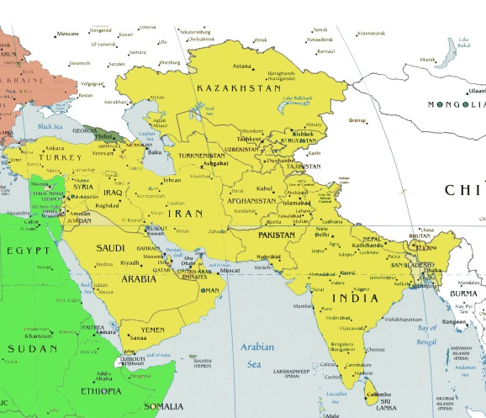
Total 1368
Figure 1: West Asia geographic region

Appendix 3
ICNA Executive Board 2010-2014
Harry Chugani (USA) Jo Wilmshurst (South Africa) Orvar Eeg-Oloffson
Ingrid Tein (Canada) Robert Ouvrier (Australia) Guillermo Agosta (Argentina)
Banu Anlar (Turkey) Hugo Arroyo (Argentina) Paolo Curatolo (Italy)
Linda De Meirleir (Belgium) Kenneth Mack (USA) Ahmed Raouf Ibrahim (Egypt)
Vijeya Ganesan (UK) Yong-Seung Hwang (Korea) Andrew Kornberg (Australia)
Lieven Lagae (Belgium) Charles Newton (Kenya) Raili Rikkonen (Finland)
Robert Rust (USA) Masaya Segawa (Japan) Michael Shevell (Canada)
Pratibha Singhi (India) Takao Takahashi (Japan) André Venter (South Africa)
Virginia Wong (Hong Kong)

